**What is Assertion ?**  
Assertion helps us to verify the conditions of the test and decide whether test has failed or passed. A test is considered successful ONLY if it is completed without throwing any exception.

There are many more methods available to assert, as per scenario we use it.

WebElement myAccount = driver.findElement(By.xpath(".//*[@id='account']/a"));

//Test will only continue, if the below statement is true

//This is to check whether the link is displayed or not

Assert.assertTrue(myAccount.isDisplayed());

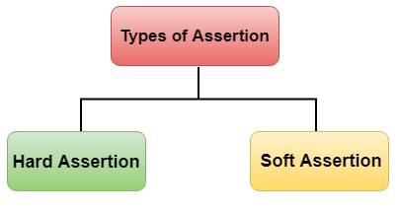

<https://www.javatpoint.com/selenium-assertions>

## Hard Assertion

Hard Assertion is an Assertion that throws the **AssertException** when the test case is failed. In the case of Hard Assertion, you can handle the error by using a catch block like a java exception. Suppose we have two test cases in a suite. The first test case in a suite has an assertion that fails, and if we want to run the second case in a suit, then we need to handle the assertion error.

SoftAssertion

In hard assertion, if an assertion fails then it aborts the test case otherwise it continues the execution. Sometimes we want to execute the whole script even if the assertion fails. This is not possible in Hard Assertion. To overcome this problem, we need to use a soft assertion in testng.